During the course of the 20th Century, physicists were on a mission to discover the inner workings of matter at the most fundamental level. With the earlier discoveries of the electron (in 1897); the proton (in 1917 by Rutherford) and the neutron (in 1932) - it was generally assumed that the search for fundamental particles had finally been concluded. But technological advancements as a result of WWII resulted in the discoveries of many new particles and the production of more sophisticated particle accelerators/detectors.

These newly discovered particles were then classified into “families” (as they shared similar properties). Labels included leptons, mesons and hadrons. All in all, by the end of these discoveries – twelve fundamental particles were found to exist, and they were all sorted into what is now known as The Standard Model. All the matter that resides in the Universe is all made up of a combination of some of these particles – when looking at it on the most basic level.

The Standard Model was first collated in 1967 by physicists Abdus Salam and Steven Weinberg (both later won the Nobel Prize for physics, for their work on fundamental particles & The Standard Model) – and from this, the current picture of the structure and behavior of matter was constructed. This model has been shown to be very successful and powerful. It correctly describes all these new particles which had been discovered during this time.

The Model also describes three of the four fundamental forces that enable the particles to interact with each other – electromagnetism, the weak and the strong force (gravity falls outside the Model)

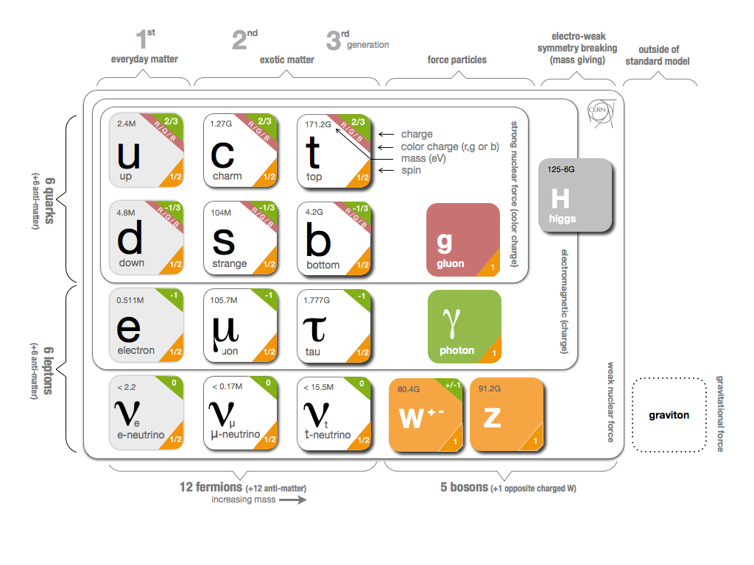Another reason for its success lies in its simplicity – consisting of only two families of fundamental particles and exchange forces which bind them together.

Figure - The Standard Model of matter (includes all the fundamental particles along with their charges & masses)

These two families of fundamental particles are known fermions and bosons:

**Fermions**

* **They possess half-integer spin**

These include all quarks; which come in six different “flavours”- up, down, strange, charm, bottom and top. The quark model was first proposed by two physicists – George Zweig and Murray Gell-Mann in 1964 as part of the original Standard Model (which started off with only three “flavours” – up, down and strange). Quarks are a type of elementary particle and thus a fundamental constituent of matter. They combine together to form composite particles (which are named hadrons), this includes protons and neutrons – which go on to create atomic nuclei. But due to “colour confinement”, quarks cannot be observed by themselves. Rather, they can only be found within hadrons – which include baryons (i.e. neutrons & protons) and mesons (which are bosons). Baryons are a type of composite particle which is usually formed from three quarks (an odd number).

Nearly everything that we know about quarks comes from observing hadrons and learning about the

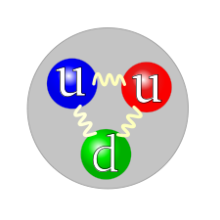forces which join the quarks together.

Figure - A proton; made up of two "up" quarks, one "down" quark and gluons which transfer the forces binding them together.

The main difference between the flavours of quarks is their masses. Other properties which quarks possess include spin, colour/ electric charge. Quarks are also the only known particles which have fractional electric charges (in terms of e – the elementary charge).

Out of the six flavours, the up and down quarks are the most prevalent – together they form protons and neutrons, and thus atomic nuclei (which make up most matter at a macroscopic level). Whilst the other four (top, bottom, charm and strange) are usually found and produced during high energy collisions (either man-made in particle accelerators or naturally via cosmic rays). Also, In addition to the six quarks mentioned, there are also six corresponding anti-quarks – which are their antiparticle counterparts. These anti-quarks only differ from the fact that some of their properties have a sign change (same magnitude, but opposite signs).

Other noteworthy fermionic elementary particles include:

Electron 🡪 has an electric charge of -e; plays an important role in phenomena such as magnetism, electricity and chemistry.

Neutrinos 🡪 only interacts via gravity and the weak force; its mass is believed to be a millionth that of an electron (for a time, it was though of to be massless)

(Note: other elementary particles such as tau and muons are not covered in my physics specification – thus my choice to omit them)

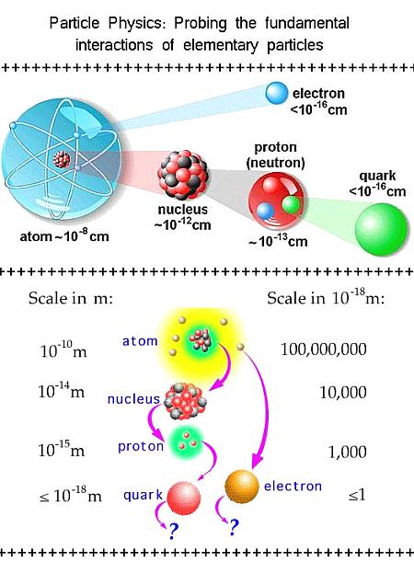

Figure - Particle Diagram showing how quarks and other elementary particles make up composite matter

**Bosons**

* **They possess integer spin**

These include the gauge bosons, which are force carriers. There are four types of gauge bosons:

* Photons – mediates the electromagnetic interaction
* W and Z bosons – carries the weak interaction
* Gluons – carries the strong force

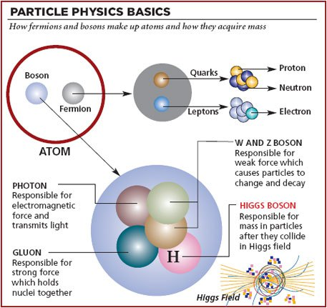

Figure - Description of boson interactions

Note: There is also the Higgs Boson but since it does not appear anywhere in the syllabus, I shall not discuss it further (falls outside the scope of the solution)